# Color Interpolation inside Wave machines

## Introduction

Wave compiled show presentation files provides information about the LED colors during a timeframe. It indicates the colors in a RGB format (from 0.000 to 1.000) for each specific time in seconds. Nevertheless it does not indicate the values of the colors among those times.

A timeframe could contain the next entry

{

"time":0,

"rgb":[0,0,0]

}, {

"time":100,

"rgb":[1,1,1]

},

A initial approach will be using a linear interpolation, nevertheless the results are not visually pleasing. A better approach is to generate the values using Bezier interpolation.

The Bezier curve is defined by

$$B\left(t\right)={(1-t)}^{3}P_{0}+{3t(1-t)}^{2}P_{1}+3t^{2}(1-t)P_{2}+t^{3}P_{3} , t ∈\left[0,1\right].$$

Where P0 and P3 are the desired initial and final values and P1 and P2 are anchor points that smooth the curve and t is the % of the generated path.

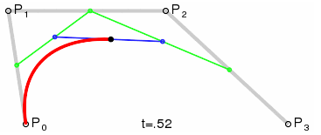

Figure The red line is the path created

The Bezier curve has to be calculated for each component (R, G and B) of the color. All values of Px have a time component (x) that will be defined as Tx and a intensity component (y) which will be defined as Ix. The variable t indicates the % of the paths being generated.

The calculation could be highly time consuming because

* Each component interpolation could take up to 26 float equation. As each color has 3 components there will be required 78 float equations per color interpolation.
* As each Wave has 16 LEDs, there will be 1248 required float equations per Wave interpolation.
* As there will be 24 Wave interpolations (frames) per second, there will be 29952 required floats equations per second.
* The variable t doesn't match the time, but the % of the path being generated, in fact a general Bezier curve might have up to 3 values for each time.

Given the huge amount of required float equations, though optimizations are required, even if the optimized approximation of the Bezier curve is not completely correct.

## Interpolation optimization

The first optimization is to make the intensity of I1 and I2 a multiple of I0 and I3 respectively.

In the case of having I1 = I0 and I2 =I3, the equation can be defined as

$$B_{y}\left(t\right)={(1-t)}^{3}I_{0}+{3t(1-t)}^{2}I_{0}+3t^{2}(1-t)I_{3}+t^{3}I_{3} , t ∈\left[0,1\right].$$

Which can be shrink to

$$B_{y}\left(t\right)=\left({ (1-t)}^{3}+{3t(1-t)}^{2}\right)I_{0}+\left(3t^{2}(1-t)+t^{3}\right)I_{3} , t ∈\left[0,1\right]. [1]$$

Another optimization is to correlate the time component (x) of the generated Bezier value with t variable. This can be done by

* Define T0 as 0 and match it to the frame of the initial interpolation time (s0).
* Define T3 as 1 and match the frame of the final interpolation time (s1).
* Define T1,x as 0.4 and T2,x as 0.6 generates and smooth curve

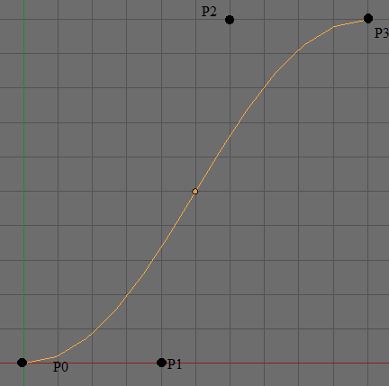

Figure Default interpolation generates smooth curve

* The value of t for each required time component Bt can be found by solving the equation
$$B_{t}={(1-t)}^{3}T_{0}+{3t(1-t)}^{2}T_{1}+3t^{2}(1-t)T_{2}+t^{3}T_{3} , B_{t}\left(t\right) ∈\left[0,1\right]$$

* By reorganizing the elements, and applying the values the new equation looks like
$$B_{t}={1.2t(1-t)}^{2}+1.8t^{2}(1-t)+t^{3} , { t∈\left[0,1\right] , B}_{t}\left(t\right) ∈\left[0,1\right]$$

* By simplifying the equation
$$B_{t}=0.4t^{3}-0.6t^{2}+1.2t, { t∈\left[0,1\right] , B}_{t}\left(t\right) ∈\left[0,1\right]$$

* Then a new equation can be defined as

$$F\left(B_{t}\right)=t,{ t∈\left[0,1\right] , B}_{x}t ∈\left[0,1\right] [2]$$

Then solving the information becomes finding the desired t from a specific time component(equation **[2]**), Bt, then applying that t value to equation **[1]** to find the interpolation of the intensity.

$$B_{I}=\left({\left(1-F\left(B_{t}\right)\right)}^{3}+{3t\left(1-F\left(B_{t}\right)\right)}^{2}\right)I_{0}+\left(3t^{2}\left(1-F\left(B_{t}\right)\right)+{F\left(B_{t}\right)}^{3}\right)I_{3} , B_{t} ∈\left[0,1\right]. [3]$$

* By defining BI0t and BI3t as

$$B_{I0}t={\left(1-t\right)}^{3}+{3t\left(1-t\right)}^{2} B_{t} ∈\left[0,1\right].$$

$$B_{I3}t=3t^{2}\left(1-t\right)+t^{3} B_{t} ∈\left[0,1\right].$$

The equation in **[3]** can be rewritten as

$$B_{I}=B_{I0}t* I_{0} + B_{I3}t* I_{3}$$

Finally, because the values of BI0t and BI3t can be pre-calculated and stored in a table. A 10000 entries table will allow all required values visible interpolation of a RGB component values. The table will indicate the Bt and its respective BI0t and BI3t.

Table Recalculated intensity interpolation values

|  |  |  |
| --- | --- | --- |
| $$B_{t}$$ | Bp0t | Bp3t |
| 0.0 | 1.0 | 0.0 |
| ... | ... | ... |
| 1.0 | 0.0 | 1.0 |

The next section will define an algorithm in pseudo code to find any color intensity with the pre-calculated table.

## Interpolation algorithm

The algorithm to generate the interpolation will be

* Given a initial Intensity I0 for a specific time so, a final one, I3 for a second time s1, and the current time st the value for Bt can be easily calculated by
$$B_{t}=\frac{s_{t}-s_{0}}{s_{1}-s_{0}}{, s}_{t} ∈\left[s_{0},s_{1}\right]$$

* Because of the linear relation between frames and seconds, the value Bt can be found for any to frames (f1 and f2) and a current frame ft by the equation
$$B_{t}=\frac{f_{t}-f_{0}}{f_{1}-f_{0}}{, f}_{t} ∈\left[f_{0},f_{1}\right]$$

* The value Bt will be used to find BI0t and BI3t in the table. With those the intensity calculation becomes

$$B_{I}=B_{I0}t* I_{0} + B_{I3}t* I_{3}$$

## Implementation

By defining a 0.001 increments in the values of Bt the table can be easy created in a JSON array without explicitly defining Bt, then the JSON Array will follow the next format

[ [ 1.000,0.000] , // BI0t and BI3t for Bt = 0.000

[ 0.999,0.001] , // BI0t and BI3t for Bt = 0.001

...

[ 0.001,0. 999] , // BI0t and BI3t for Bt = 0.999

[ 0.000,1.000] , // BI0t and BI3t for Bt = 1.000

]

## Bibliography

http://en.wikipedia.org/wiki/B%C3%A9zier_curve